An organisation can track its sales in segmented area by parsing the address and counting the number of orders subsequently.

An administrator can filter the area with a dropdown where he can select the area of his desire for analysis.

According to data a report will be generated in which will display the statistics as below:

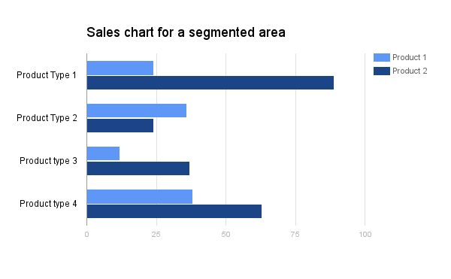

Additional features that can be added are:

* Push/SMS notification to customers in the area.